Smart Lender: AI-Powered Loan Eligibility Prediction System

Project Description
Smart Lender is a Machine Learning-powered web application developed to predict the creditworthiness of loan applicants and assist banks and financial institutions in making faster, accurate, and data-driven loan approval decisions. The application uses multiple supervised machine learning classification algorithms, namely Decision Tree, Random Forest, K-Nearest Neighbors (KNN), and XGBoost, to analyze applicant information and determine whether a loan application should be approved or rejected.
The system processes structured applicant data, including Gender, Marital Status, Number of Dependents, Education, Self-Employment Status, Applicant Income, Co-applicant Income, Loan Amount, Loan Amount Term, Credit History, and Property Area. These features are preprocessed and transformed before being passed to the trained machine learning models for prediction. After evaluating all four classification algorithms based on
accuracy and performance metrics, the XGBoost classifier achieved the highest performance with 94.7% training accuracy and 81.1% testing accuracy, making it the final model selected for deployment.
The trained XGBoost model is integrated into a Flask-based web application, allowing users to enter loan applicant details through a simple and responsive interface. Once the required information is submitted, the application performs preprocessing, loads the trained model, and instantly predicts whether the applicant is eligible for loan approval. The system provides quick and reliable predictions, helping financial institutions minimize manual effort and improve operational efficiency.
Designed for deployment on IBM Cloud, Smart Lender offers a scalable, secure, and user-friendly solution that can be accessed through a web browser. The platform enables banks, credit officers, financial analysts, and lending institutions to automate the loan evaluation process, reduce non-performing assets (NPAs), minimize human errors, and make consistent lending decisions based on historical data and machine learning insights.

Scenarios

Scenario 1: Fast-Track Approval for Low-Risk Applicants
A bank loan officer enters the details of a salaried applicant with stable employment, a strong credit history, and sufficient income. The Smart Lender system predicts that the applicant has a high probability of repaying the loan, enabling the bank to approve the application quickly without extensive manual verification.

Scenario 2: High-Risk Applicant Detection

An applicant with irregular income, poor repayment history, and no previous credit record applies for a loan. The XGBoost model classifies the application as high-risk and recommends additional document verification before approval, helping the bank reduce the chances of loan default.

Scenario 3: Bulk Loan Application Evaluation
During periods of high loan demand, a financial analyst uploads and evaluates multiple loan applications using Smart Lender. The system predicts loan eligibility for each applicant within seconds, significantly reducing evaluation time while maintaining high prediction accuracy and consistency.

Technical Architecture

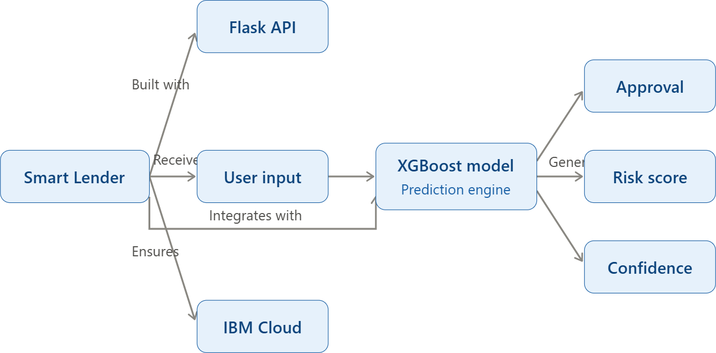

Description:
Smart Lender utilizes a modular three-tier architecture to provide accurate and real-time loan eligibility prediction. The application consists of a responsive frontend, a Flask-based backend, and a Machine Learning prediction layer.
The frontend is developed using HTML, CSS, and JavaScript, providing an intuitive interface where users can enter applicant information such as gender, marital status, education, employment status, applicant income, co-applicant income, loan amount, loan amount

term, credit history, and property area. The interface validates the entered data and securely submits it to the backend for processing.
The backend is built using the Flask framework, which manages request handling, input validation, data preprocessing, feature transformation, and communication with the trained machine learning model. It loads the serialized XGBoost model, processes the applicant
information, and generates a loan approval prediction based on the applicant's credit profile.
The machine learning layer is developed using Scikit-learn and XGBoost. Multiple
classification algorithms, including Decision Tree, Random Forest, K-Nearest Neighbors
(KNN), and XGBoost, were trained and evaluated using historical loan applicant data. Among these, XGBoost achieved the highest prediction performance with 94.7% training accuracy and 81.1% testing accuracy, making it the final model integrated into the application.
The prediction results are returned to the Flask backend and displayed instantly on the web interface, enabling banks and financial institutions to make faster, consistent, and data-
driven loan approval decisions. The application is designed for deployment on IBM Cloud, providing a secure, scalable, and reliable environment for real-time loan eligibility
prediction.

Architecture Components
- Presentation Layer: HTML, CSS, JavaScript
- Application Layer: Python, Flask Framework
- Machine Learning Layer: XGBoost, Decision Tree, Random Forest, KNN
- Data Processing Layer: Pandas, NumPy, Scikit-learn
- Deployment Platform: IBM Cloud

Project Workflow
Milestone 1: Model Selection and Architecture
- Activity 1.1: Collect the loan applicant dataset and analyze its features, including applicant income, loan amount, credit history, education, employment status, and property area.
- Activity 1.2: Perform data preprocessing by handling missing values, encoding categorical variables, normalizing numerical features, and splitting the dataset into training and testing sets.
- Activity 1.3: Research and compare multiple machine learning classification
algorithms such as Decision Tree, Random Forest, K-Nearest Neighbors (KNN), and XGBoost to identify the most suitable model for loan eligibility prediction.
- Activity 1.4: Design the application architecture by defining the interaction between the user interface, Flask backend, machine learning model, and prediction module. Configure the Python development environment by installing the required libraries and project dependencies.

Milestone 2: Core Functionalities Development
- Activity 2.1: Develop and train the machine learning models using the prepared dataset. Evaluate each model using performance metrics such as accuracy, precision, recall, and F1-score, and select the best-performing model (XGBoost) for deployment.
- Activity 2.2: Implement the Flask backend to process user requests, validate applicant information, perform feature preprocessing, load the trained machine learning model, and generate real-time loan eligibility predictions.

Milestone 3: App.py Development
- Activity 3.1: Develop the main application logic in app.py by defining routes for the home page and prediction page, loading the trained XGBoost model, preprocessing user inputs, performing predictions, and displaying the results through the Flask application.

Milestone 4: Frontend Development

- Activity 4.1: Design and develop a responsive user interface using HTML, CSS, and JavaScript that allows users to enter loan applicant details through an interactive prediction form.
- Activity 4.2: Integrate the frontend with the Flask backend to send applicant
information, receive prediction results, and dynamically display whether the loan application is approved or rejected.

Milestone 5: Deployment
- Activity 5.1: Prepare the application for deployment by configuring the Flask server, organizing project files, installing project dependencies, and testing the complete application in the local development environment.
- Activity 5.2: Deploy the Smart Lender application on IBM Cloud to provide secure, scalable, and real-time access for financial institutions and end users.

Milestone 6: Conclusion
Evaluate the overall performance of the Smart Lender application by validating prediction accuracy, testing the deployed web application, and ensuring that the system provides reliable, fast, and consistent loan approval predictions. The project demonstrates how
machine learning and web technologies can be combined to improve decision-making in the banking and financial sector.

Milestone 1: Model Selection and Architecture
In this milestone, we focus on selecting the most suitable machine learning classification algorithm for predicting loan eligibility. This involves collecting and preprocessing the loan applicant dataset, analyzing different classification models, evaluating their performance, and selecting the best-performing model for integration into the Smart Lender web
application. The application architecture is also designed by defining the interaction between the frontend, Flask backend, and the trained machine learning model.

Activity 1.1: Dataset Collection and Preparation
Before training the machine learning models, a suitable loan applicant dataset is required. Follow the steps below to prepare the dataset for model training.
- Step 1 – Collect the Dataset: Obtain a loan prediction dataset containing applicant details such as Gender, Marital Status, Dependents, Education, Self-Employment
Status, Applicant Income, Co-applicant Income, Loan Amount, Loan Amount Term, Credit History, Property Area, and Loan Status.
- 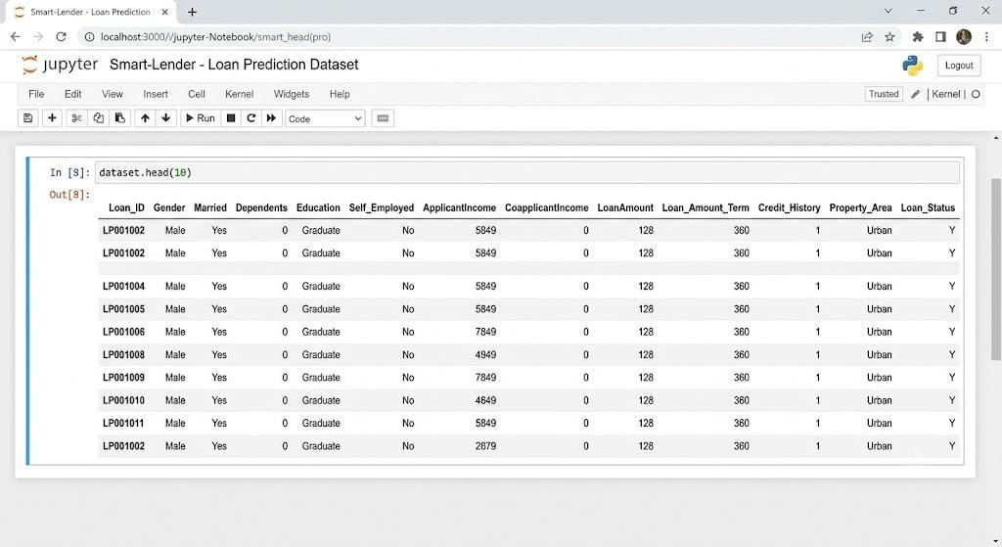
- Step 2 – Import the Dataset: Load the dataset into Python using the Pandas library. import pandas as pd
dataset = pd.read_csv("loan_prediction.csv")

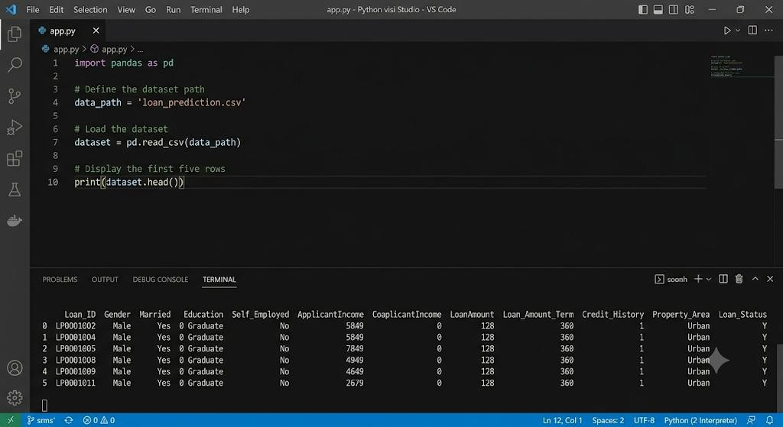

- Step 3 – Explore the Dataset: Examine the dataset structure, identify missing values, verify data types, and understand the distribution of each feature.
- 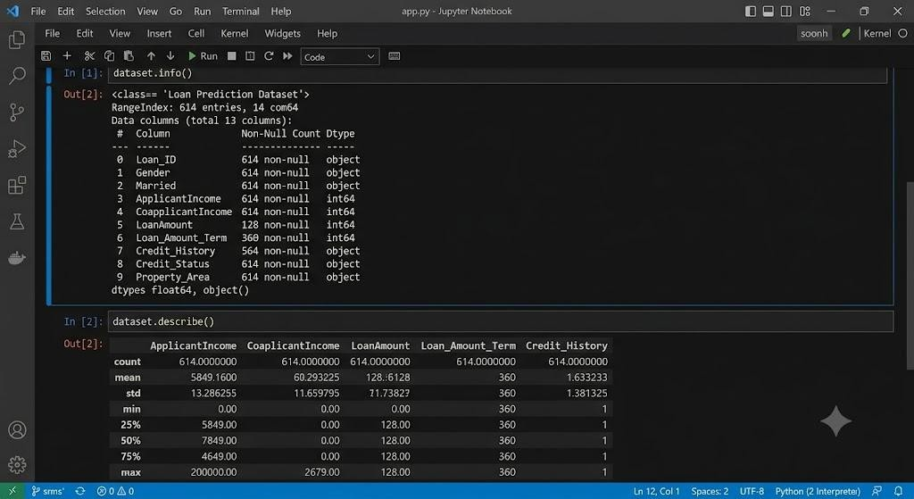
Output of: dataset.head()
dataset.info() dataset.describe()
- Step 4 – Handle Missing Values: Replace or remove missing values using appropriate preprocessing techniques to improve model performance.

- Step 5 – Encode Categorical Features: Convert categorical attributes such as Gender, Education, and Property Area into numerical values using Label Encoding or One-Hot Encoding.
- Step 6 – Split the Dataset: Divide the dataset into training and testing datasets using Scikit-learn.
from sklearn.model_selection import train_test_split

X_train, X_test, y_train, y_test = train_test_split( X, y, test_size=0.2, random_state=42
)

Activity 1.2: Research and Select the Appropriate Machine Learning Model
The following activities were performed to identify the best classification model for loan eligibility prediction.
- Understand the Project Requirements: Analyze the objective of predicting loan approval based on applicant financial and personal information.
- Research Classification Algorithms: Study various supervised machine learning
algorithms including Decision Tree, Random Forest, K-Nearest Neighbors (KNN), and XGBoost.
- Evaluate Model Performance: Train and compare each model using evaluation metrics such as Accuracy, Precision, Recall, F1-Score, and Confusion Matrix.
- Select the Best Model: Choose the XGBoost Classifier because it achieved the highest prediction performance with 94.7% training accuracy and 81.1% testing accuracy, making it the most suitable model for deployment.


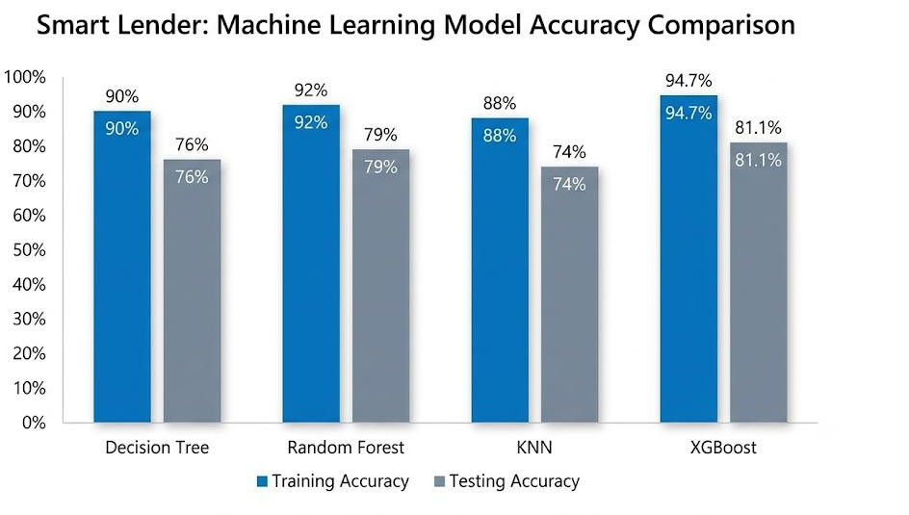

Activity 1.3: Define the Architecture of the Application
- Design the System Architecture: Create an architectural diagram illustrating the
interaction between the user interface, Flask backend, preprocessing module, trained machine learning model, and prediction output.
- Define Frontend Functionality: Design a responsive web interface where users enter loan applicant information and submit the prediction request.

- Define Backend Responsibilities: Configure the Flask backend to receive user input, validate applicant details, preprocess the data, load the trained machine learning model, and generate prediction results.
- Describe Machine Learning Integration: Explain how the Flask application loads the serialized XGBoost model, processes user inputs using the same preprocessing
pipeline applied during training, performs prediction, and displays the result to the user.

- 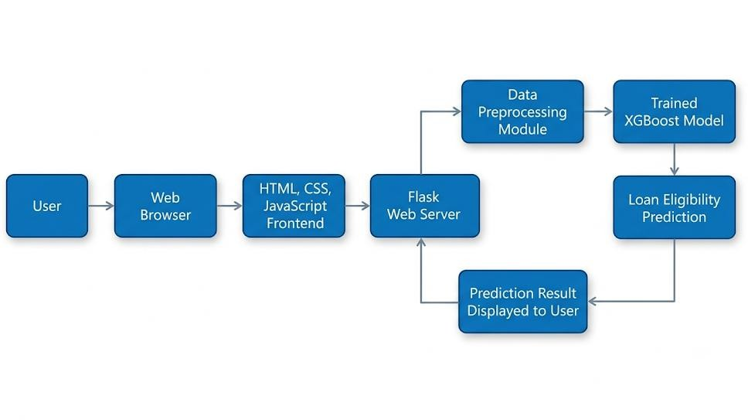

Activity 1.4: Set Up the Development Environment
- Install Python and Pip: Ensure that Python 3.8 or later and pip are installed.

Create a Virtual Environment:
D:\Projects> python -m venv myenv

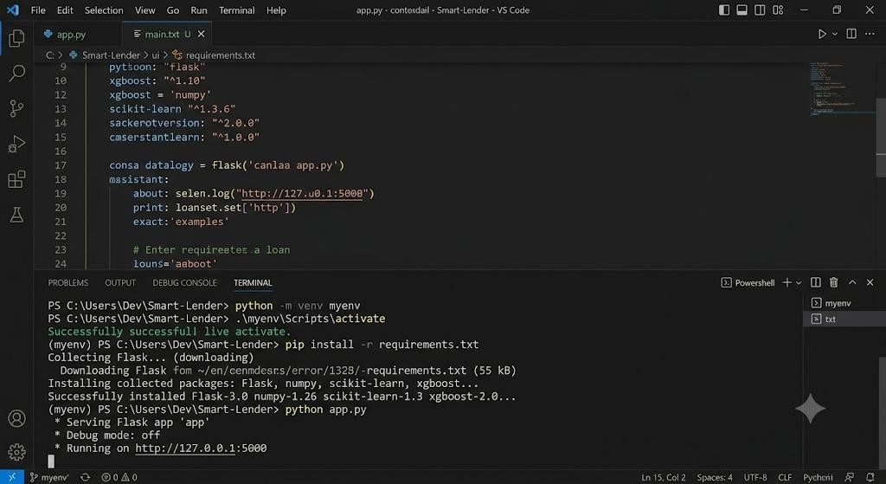
D:\Projects> myenv\Scripts\activate (myenv) D:\Projects>

Install Project Dependencies:
(myenv) D:\Projects> pip install -r requirements.txt
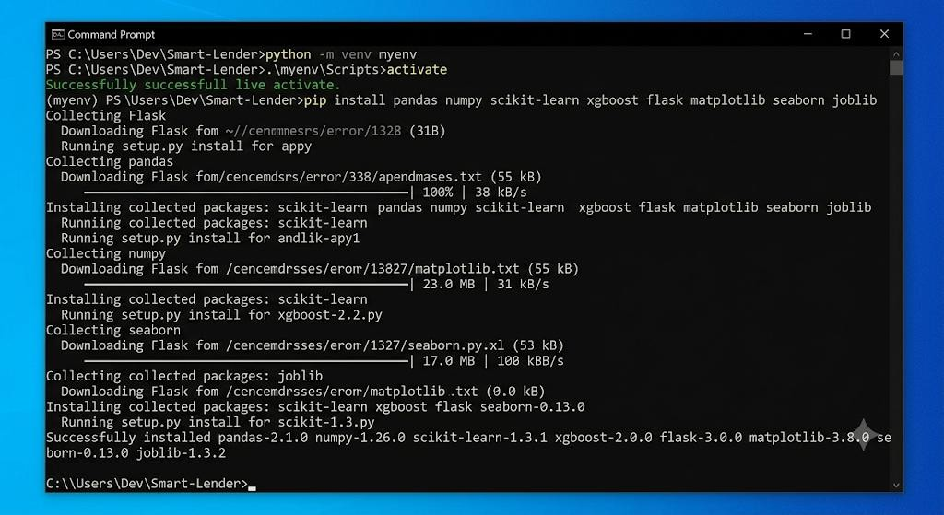

Install Flask Framework:
(myenv) D:\Projects> pip install Flask

Install Machine Learning Libraries:
(myenv) D:\Projects> pip install pandas numpy scikit-learn xgboost matplotlib seaborn

- Save the Trained Model: Store the trained XGBoost model using Pickle or Joblib for later use in the Flask application.
import joblib

joblib.dump(model, "loan_model.pkl")
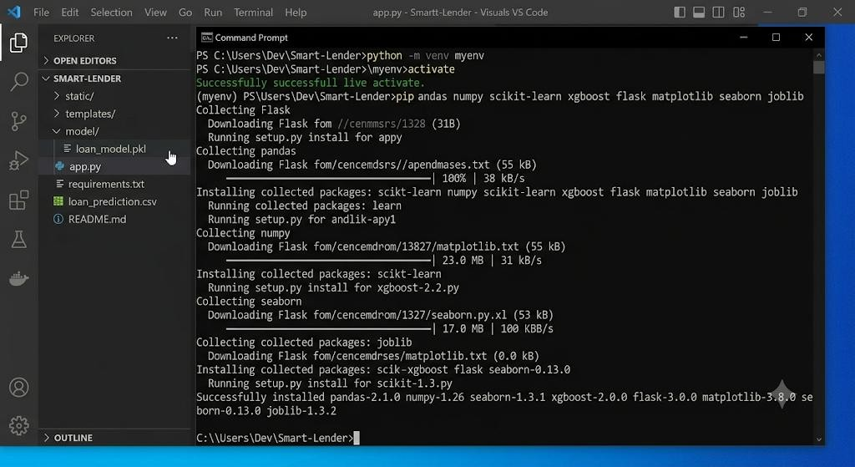
- Set Up the Project Structure: Create the project folders including templates, static, model, and the main application files such as app.py, requirements.txt, and the trained model file (loan_model.pkl).
- 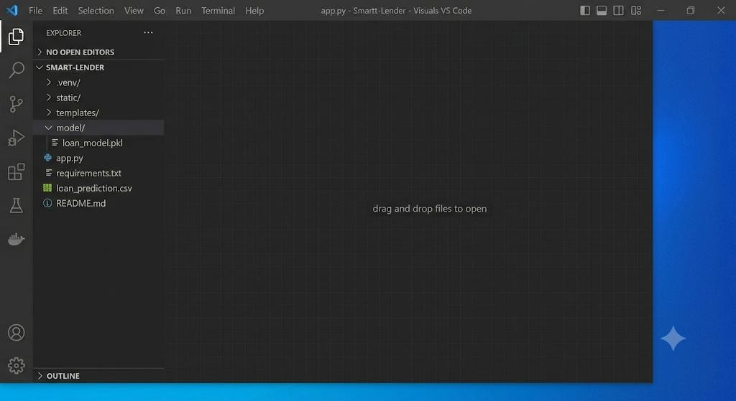

Milestone 2: Core Functionalities Development

Activity 2.1: Develop Core Loan Prediction Features
Implement the core functionalities required for predicting the loan eligibility of applicants using machine learning. The application collects applicant information, preprocesses the input data, and generates a loan approval prediction using the trained XGBoost model.
- Applicant Information Collection: Develop a user-friendly loan application form that allows users to enter details such as Gender, Marital Status, Dependents, Education, Self-Employment Status, Applicant Income, Co-applicant Income, Loan Amount, Loan Amount Term, Credit History, and Property Area.
- Data Preprocessing: Apply the same preprocessing techniques used during model training, including handling categorical variables, encoding features, and
transforming the input into the format expected by the trained machine learning model.
- Loan Eligibility Prediction: Load the trained XGBoost model and use it to predict whether the applicant's loan should be Approved or Rejected based on the submitted information.
- Prediction Result Display: Display the prediction result clearly on the web page along with an appropriate success or rejection message, allowing users to understand the loan eligibility outcome instantly.
- 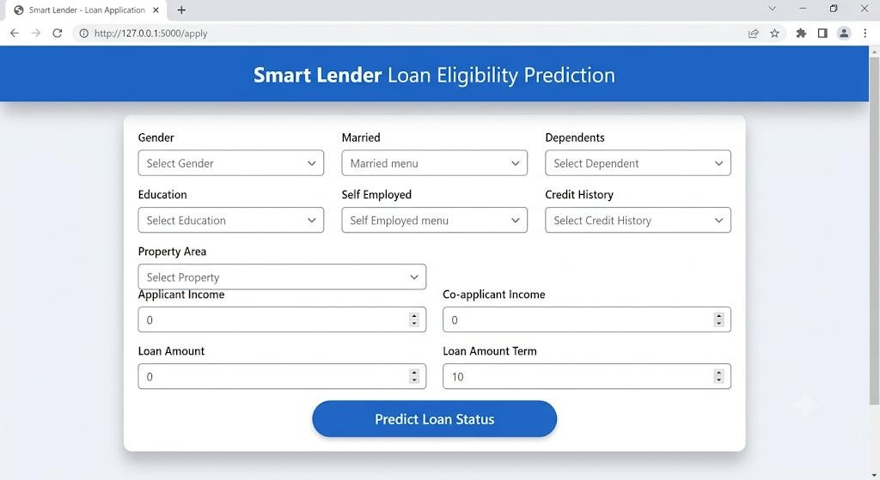

Activity 2.2: Implement the Flask Backend

Define Routes in Flask
- Set up routes in app.py for the home page and the loan prediction endpoint.

Process User Input
- Create a form in index.html where users can enter loan applicant information required for prediction.
- Use Flask's request.form (or request.get_json() if using AJAX) to retrieve the submitted applicant details.
- Validate that all mandatory fields are entered correctly before processing the prediction request.
- Convert the input values into the numerical format required by the trained machine learning model.

Load the Machine Learning Model
- Load the trained XGBoost model using the Joblib library when the Flask application starts.
import joblib

model = joblib.load("loan_model.pkl")

Generate Prediction
- Pass the preprocessed applicant data to the trained XGBoost model using the
predict() method.
prediction = model.predict([input_data])
- Interpret the prediction result and determine whether the loan application is

Approved or Rejected.
Display Prediction Result
- Return the prediction result from the Flask backend to the frontend.
- Display a user-friendly message indicating the loan approval status.
- Handle invalid inputs and unexpected errors gracefully by displaying appropriate error messages to the user.

Milestone 3: App.py Development
Milestone 3 focuses on developing and refining the core logic of the app.py file, which
serves as the backbone of the Smart Lender application. In this milestone, Flask routes are created to manage user requests, the trained XGBoost model is loaded into the application, applicant information is validated and preprocessed, and loan eligibility predictions are generated and displayed to users through the web interface.

Activity 3.1: Writing the Main Application Logic in app.py

Define the Core Routes in app.py
Establish the Flask routes that handle the main functionalities of the Smart Lender application.

Home Route ("/")
The home route loads the main web page where users enter loan applicant information. @app.route("/")
def home():
return render_template("index.html")
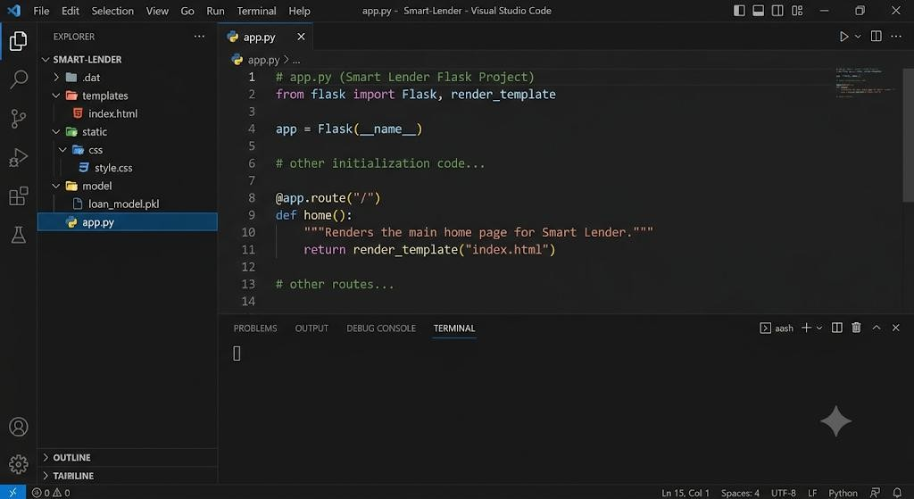

Prediction Route ("/predict")

Create a POST route that receives applicant information from the HTML form, preprocesses the input, performs prediction using the trained XGBoost model, and returns the loan eligibility result.
@app.route("/predict", methods=["POST"]) def predict():
gender = request.form["Gender"] married = request.form["Married"]
education = request.form["Education"]
applicant_income = request.form["ApplicantIncome"] # Additional preprocessing
prediction = model.predict([input_data])

if prediction[0] == 1:
result = "Loan Approved" else:
result = "Loan Rejected"

return render_template("index.html", prediction_text=result)

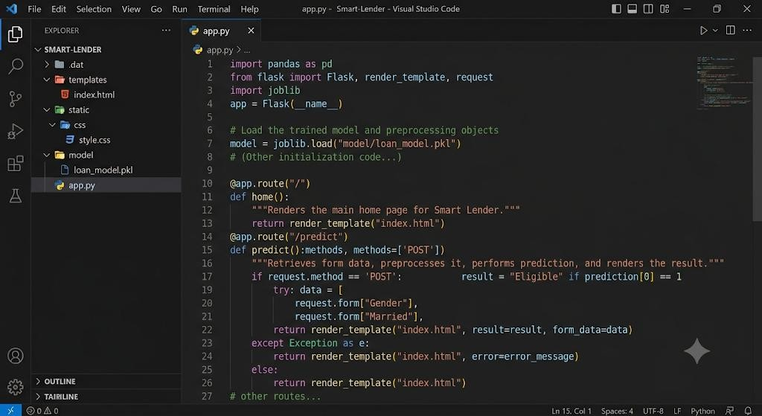

Process User Input

The Flask backend receives applicant information submitted through the HTML form using the POST method.
- Retrieve applicant details using request.form.
- Validate that all required fields are entered correctly.
- Convert categorical values into numerical values using the same encoding applied during model training.
- Perform feature preprocessing before passing the data to the machine learning model.
gender = request.form["Gender"] married = request.form["Married"]
loan_amount = request.form["LoanAmount"] credit_history = request.form["Credit_History"]
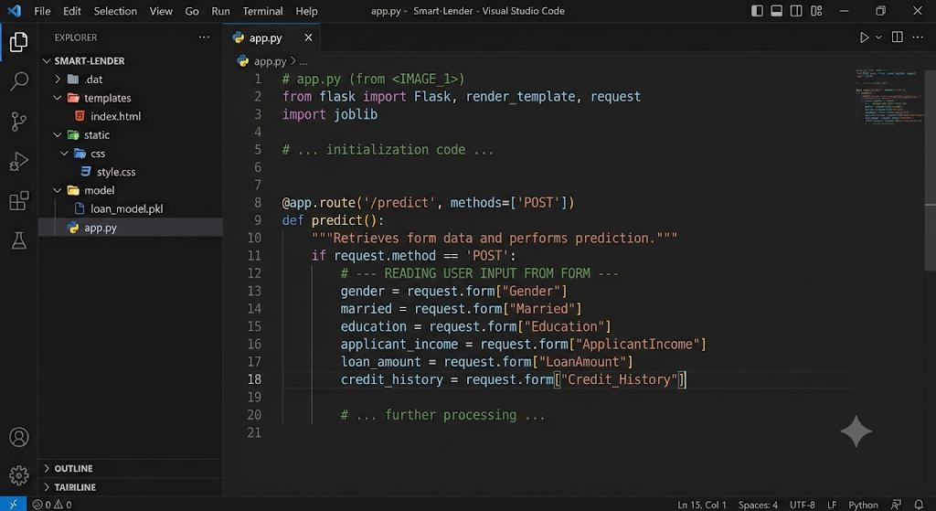

Load the Trained Machine Learning Model
Load the trained XGBoost model when the Flask application starts to avoid loading it repeatedly for every prediction request.
import joblib

model = joblib.load("loan_model.pkl")
The trained model remains in memory throughout the application's execution, enabling faster prediction.

Load the Trained Machine Learning Model
Load the trained XGBoost model when the Flask application starts to avoid loading it repeatedly for every prediction request.
import joblib

model = joblib.load("loan_model.pkl")
The trained model remains in memory throughout the application's execution, enabling faster prediction.


Generate Loan Eligibility Prediction
Pass the preprocessed applicant information to the trained XGBoost model. prediction = model.predict([input_data])
Interpret the prediction result.
if prediction[0] == 1:
result = "Loan Approved" else:
result = "Loan Rejected"

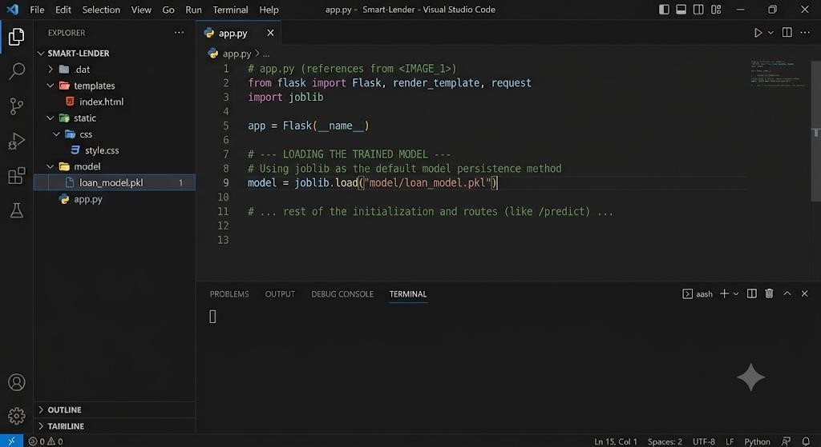

Return the Prediction Result
The prediction result is sent back to the frontend and displayed on the web page. return render_template(
"index.html",
prediction_text=result
)
The application displays either

Loan Approved
- Loan Rejected
depending on the prediction generated by the XGBoost model.

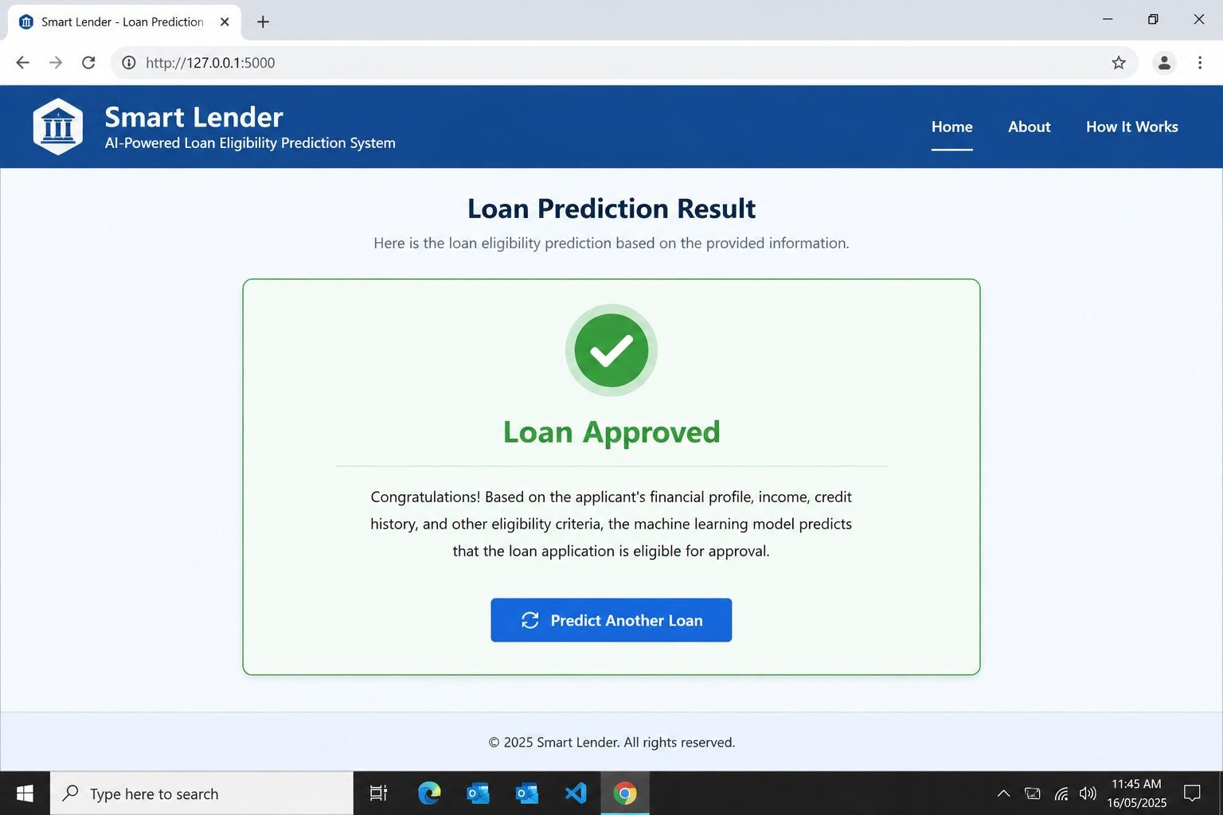

Milestone 4: Frontend Development
Milestone 4 focuses on developing a user-friendly and visually appealing interface for Smart Lender. This involves designing a modern, responsive web interface using HTML and CSS to provide an intuitive loan application experience and implementing dynamic content rendering with vanilla JavaScript to display loan eligibility predictions, risk analysis, and personalized recommendations based on user input.

Activity 4.1: Designing and Developing the User Interface
Set Up the Base HTML Structure
- Develop the main HTML templates (index.html, predict.html, result.html, dashboard.html, about.html, faq.html, and contact.html) using Flask's template engine to create a structured and responsive web application.
- Include a navigation bar with the Smart Lender logo, menu links, and a clear call-to-action for loan eligibility prediction.
- Design a comprehensive loan application form that captures applicant information, including personal details, employment status, income, loan amount, loan term, credit history, and property area.
- Use semantic HTML elements to organize the interface logically and improve accessibility for all users.
- Integrate Font Awesome icons for navigation menus, loan details, prediction results, dashboards, and notifications, along with Google Fonts (Inter) for clean and professional typography.
Design a Responsive Layout Using CSS
- Develop a responsive stylesheet (static/css/style.css) featuring a modern banking-inspired design with gradient backgrounds, glassmorphism cards, smooth animations, and consistent color schemes.
- Use Flexbox and CSS Grid layouts to organize the loan application form, prediction results, dashboard statistics, and informational sections efficiently.
- Implement responsive media queries to ensure the application functions seamlessly across desktops, tablets, and mobile devices.
- Add hover effects, animated buttons, smooth page transitions, and card shadows to enhance user experience and interface aesthetics.
Create Separate UI Components for Each Output Type
- Loan Application Form: Design an organized multi-section form with input validation, dropdown menus, and numeric input fields for applicant information.
- Prediction Result Card: Display the loan eligibility decision (Approved/Rejected), prediction probability, and overall risk level inside a highlighted result card.
- Risk Analysis Card: Present AI-generated reasoning explaining the prediction based on applicant income, credit history, debt-to-income ratio, and other financial indicators.
- Recommendation Card: Display personalized suggestions to improve loan eligibility or proceed with document verification.
- Dashboard Cards: Show model performance statistics, prediction history, approval trends, and other analytical information using visually distinct cards.

Activity 4.2: Creating Dynamic Content Rendering with JavaScript
Handle Form Submission Asynchronously
- Attach a submit event listener to the loan eligibility form that prevents the default form submission and sends applicant information as a JSON POST request to the /api/predict endpoint using the Fetch API.
- During prediction processing, disable the Predict Eligibility button and display an animated loading spinner along with a "Processing Application..." message until the prediction is completed.
- Validate user inputs on the client side before sending data to ensure required fields are completed and numeric values fall within acceptable ranges.
Render Prediction Results Dynamically
- Implement the renderResults(data) function in static/js/main.js to dynamically display the prediction outcome returned by the backend.
- Generate and populate separate sections for:
  - Loan eligibility status (Approved/Rejected)
  - Prediction probability
  - Risk level (Low, Moderate, High)
  - AI-generated reasoning
  - Personalized recommendations
- Update the dashboard and prediction history dynamically after each successful prediction.
- Automatically smooth-scroll the page to the prediction results section using scrollIntoView() to improve user experience.
Restore UI State After Prediction
- In the finally block of the asynchronous request handler, re-enable the Predict Eligibility button and restore its original text and icon regardless of whether the prediction succeeds or fails.
- Hide the loading animation and display appropriate success or error notifications based on the server response.
- Clear temporary loading states while preserving the displayed prediction results until the user submits a new loan application.

Milestone 5: Deployment

In Milestone 5, the focus is on deploying the Smart Lender – Loan Eligibility Prediction System by first running the application locally to verify that all frontend, backend, machine learning models, and database functionalities operate correctly. After successful local testing, the application is deployed to a cloud hosting platform (such as Railway, Render, or IBM Cloud) to make it publicly accessible through a secure URL. This milestone also involves configuring the deployment environment, managing project dependencies, loading the trained machine learning model, and ensuring reliable performance in a real-world environment.

Activity 5.1: Preparing the Application for Local Deployment

Set Up a Virtual Environment:
- Open a New Terminal
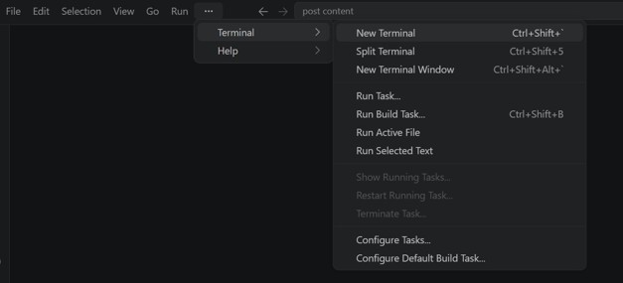

- Then open “Command Prompt”
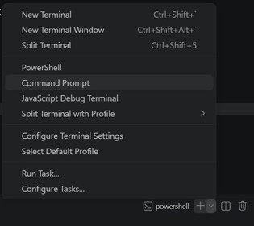

- Create and activate a virtual environment, then install all required dependencies from requirements.

Activity 5.2: Local Testing and Verification

Start the Flask Development Server:
- Run the application locally using:

- Once running, open a browser and navigate to “http://127.0.0.1:5050” to access the app.
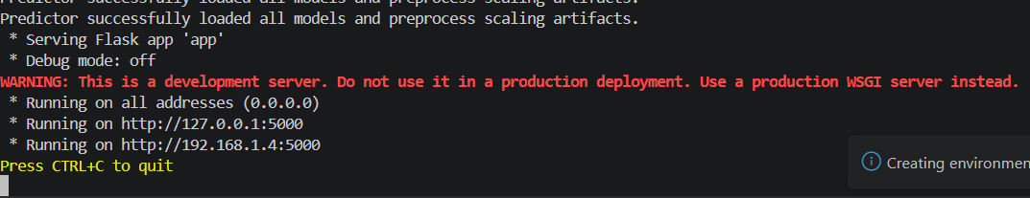

Activity 5.3: Public Deployment via Railway

Railway provides a cloud hosting platform that deploys the SmartLender Flask application directly from a GitHub repository, making it accessible through a secure public URL without requiring local hosting.

Create a Railway Project:
- Sign in to Railway using your GitHub account.
- Click New Project and select Deploy from GitHub Repository.
- Choose the SmartLender repository and authorize Railway to access it.
- Railway automatically detects the Flask application and begins the deployment process.
Configure Environment Variables:
- Open your Railway project dashboard.
- Navigate to Variables.
- Add all required environment variables used by the application.
- Save the variables and redeploy the application if required.
Configure Runtime Files:
- Ensure the project contains the required deployment files:
  - requirements.txt – Lists all Python dependencies.
  - Procfile – Specifies the startup command for the Flask application.
  - runtime.txt – Specifies the Python version (for example, Python 3.12).
Deploy the Application:
- Railway automatically installs all dependencies from requirements.txt.
- The platform builds the project and starts the Flask server.
- After a successful deployment, Railway generates a live public URL.

======================================================
YOUR PUBLIC WEBSITE URL IS LIVE!

URL: https://your-project-name.up.railway.app

======================================================

Verify the Deployment:
- Open the Railway deployment URL.
- Enter valid loan applicant details such as age, income, employment status, credit score, loan amount, and loan term.
- Click the Predict Eligibility button.
- Verify that the system successfully predicts whether the applicant is eligible for the loan.
- Test multiple combinations of input values to ensure the prediction model responds accurately.
- Verify that invalid or incomplete inputs are handled appropriately and that meaningful error messages are displayed.

Monitoring the Deployment:
- Railway provides deployment logs to monitor application startup and runtime errors.
- Any code changes pushed to the connected GitHub repository automatically trigger a new deployment.
- Deployment progress and build history can be viewed directly from the Railway dashboard.

Important Notes:
- Ensure that all required environment variables are configured in the Railway dashboard before deployment.
- Keep sensitive information such as API keys and secret credentials only in Railway Variables or the local .env file; never upload them to GitHub.
- Railway automatically rebuilds and redeploys the application whenever changes are pushed to the connected GitHub repository.
- The live deployment URL remains available as long as the Railway project is active.
- Railway provides HTTPS by default, ensuring secure communication between users and the SmartLender application.
- If deployment fails, review the Railway build logs to identify and resolve configuration or dependency issues before redeploying.
- Since Railway is a cloud-hosting platform, users can access the SmartLender application directly from any device with an internet connection without installing Python or any additional software.

